**Kubernetes Task**

Launched instance

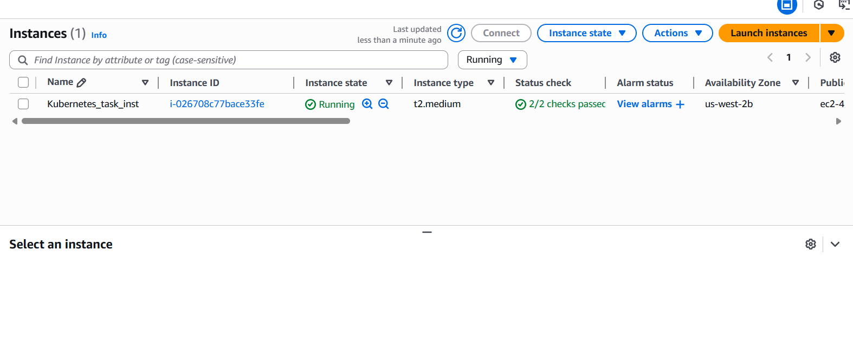

Installed Docker

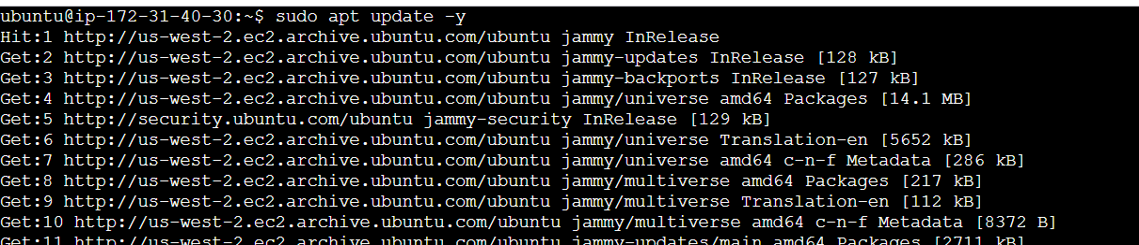

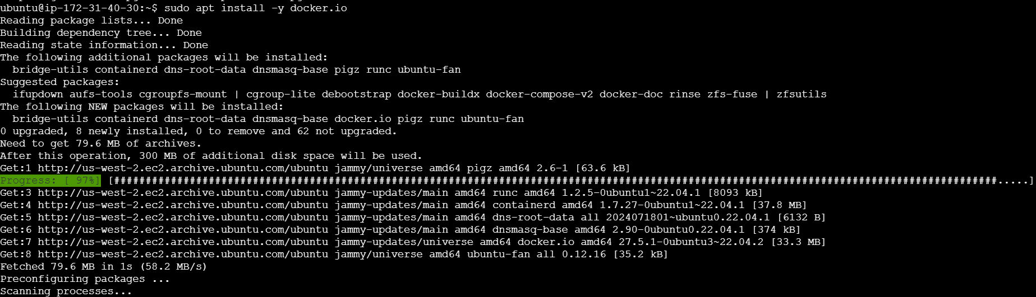

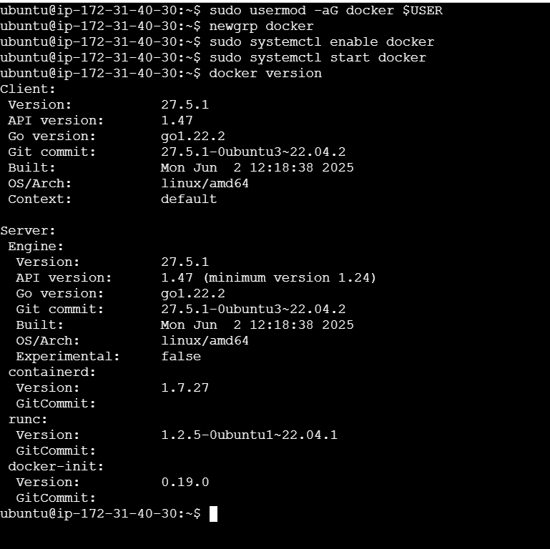

Installed Minikube

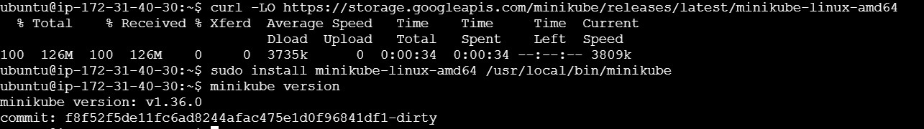

Installed kubectl

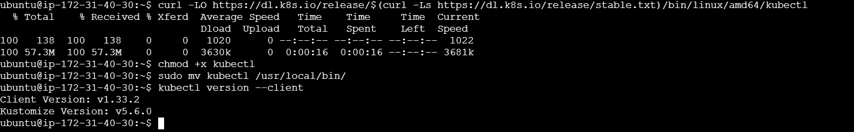

Started Minikube with Docker driver

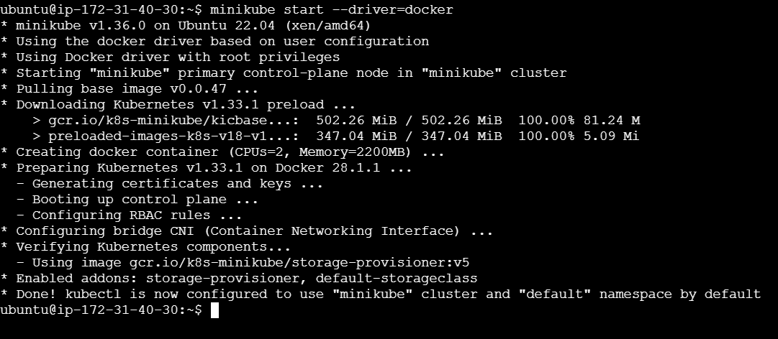

Created, explored, cleaned up & verified Namespaces

